Chapter 3, Solution 72

By inspection, write the mesh-current equations for the circuit in Fig. 3.116.

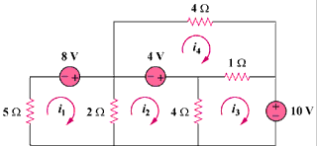

Figure 3.116
For Prob. 3.72.

Solution

R₁₁ = 5 + 2 = 7, R₂₂ = 2 + 4 = 6, R₃₃ = 1 + 4 = 5, R₄₄ = 1 + 4 = 5,
R₁₂ = -2, R₁₃ = 0 = R₁₄, R₂₁ = -2, R₂₃ = -4, R₂₄ = 0, R₃₁ = 0,
R₃₂ = -4, R₃₄ = -1, R₄₁ = 0 = R₄₂, R₄₃ = -1, we note that R_{ij} = R_{ji} for
all i not equal to j.

v₁ = 8, v₂ = 4, v₃ = -10, and v₄ = -4

Hence the mesh-current equations are:

